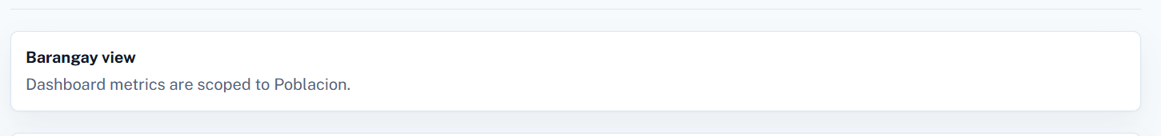
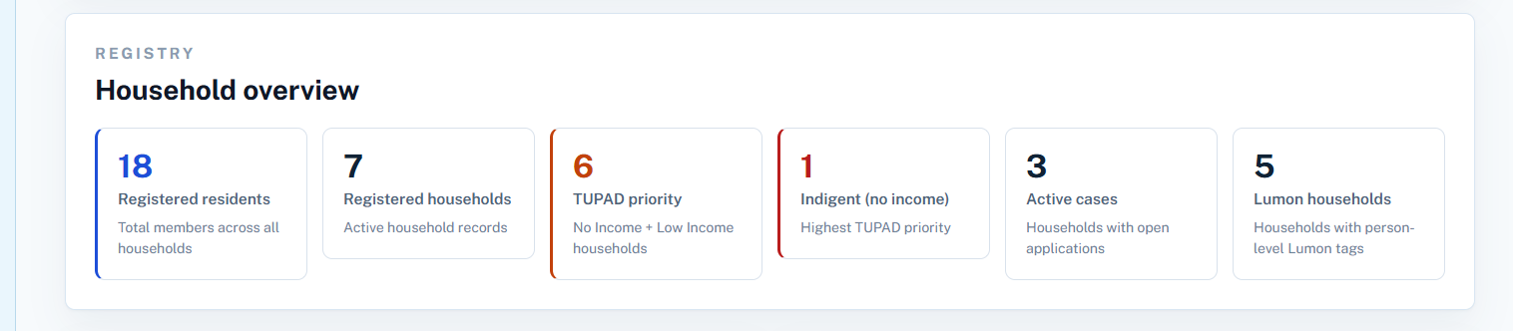

Barangay distribution no.
- Per program
- Per beneficiaries

Automatic save when disabled button clicked
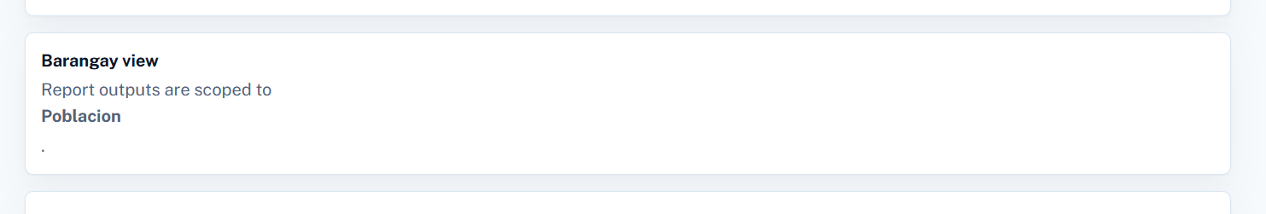

Recommendations module
- Approved
- Rejected
-

Ranking
Family members numbers
Work
Income

